Accessing Software through Microsoft Dreamspark

Students taking courses in the Information Systems and Decision Science department at UB are entitled to free software provided through the Microsoft Dreamspark Premium program. The software is typically full / enterprise versions of products, it is free, and the software does not expire.
Please note, access to the dreamspark “store” is available only in semesters in which you are enrolled in an INSS or OPRE course.
To obtain software, follow the instructions below:

Step 1

Go to www.dreamspark.com and the click on the Learn More link under the Access Your Subscription area.
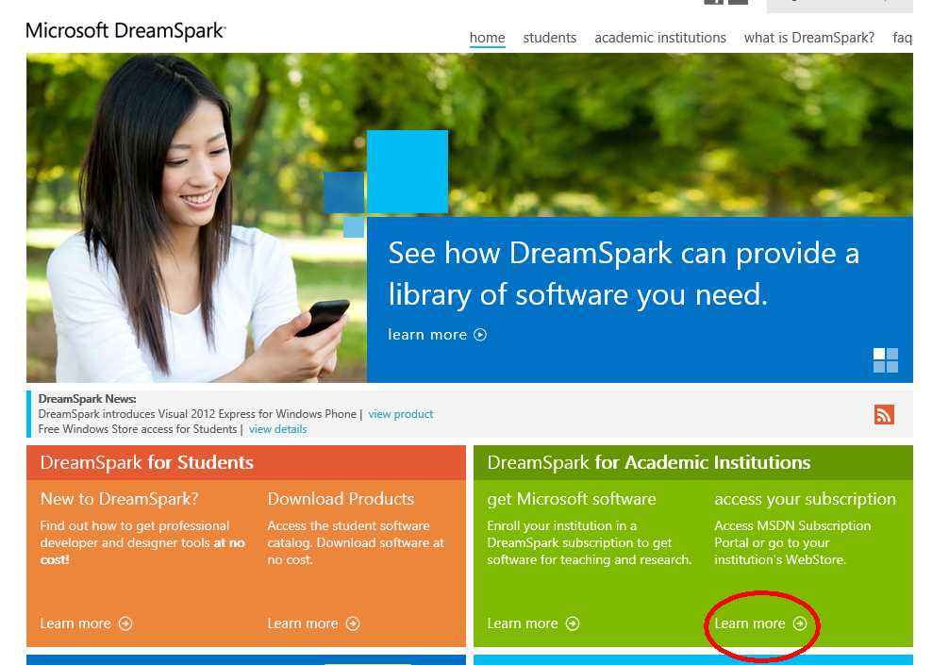

Step 2

Type “Baltimore” into the drop down box, to find the correct ELMS webstore for UB. Make sure you choose the correct UB department – Information Systems and Decision Science.
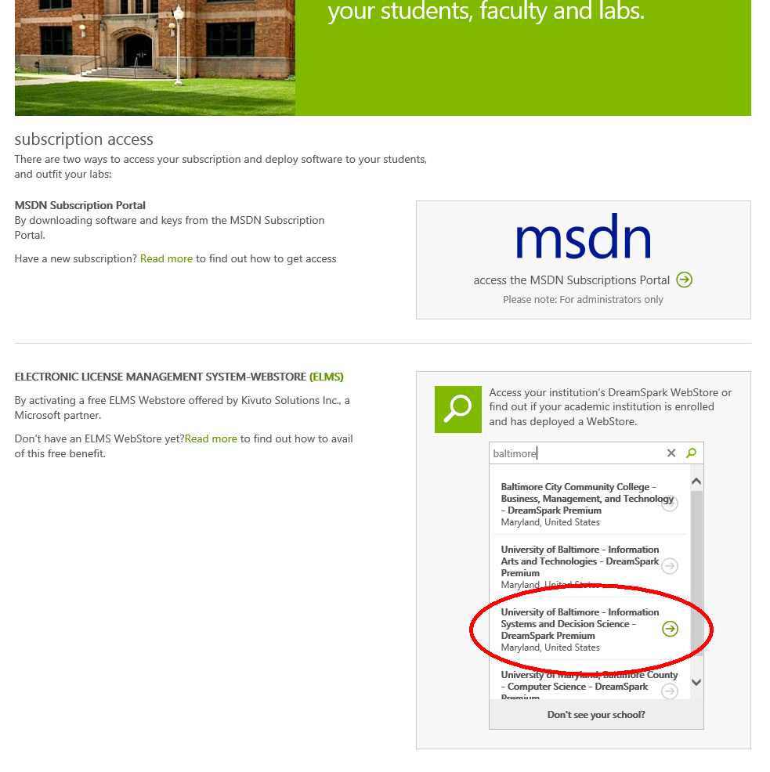

Step 3

Once found, click on the Visit Webstore arrow.
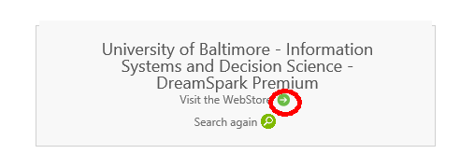

Step 4

You should now be in the UB / ISDS webstore. Browse through the products to find what you are looking for. Be sure to notice the different versions (e.g. 32 bit and 64 bit Windows versions and so on) and choose the appropriate product. Add the product to your cart.
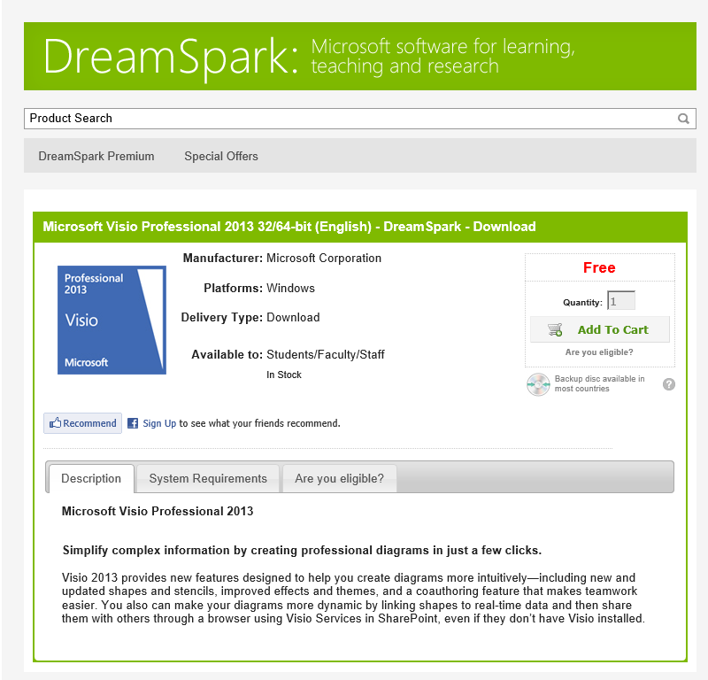
At this stage Microsoft needs to know you are a valid UB student. You will be directed to the UB login page, where you should log in with your UB network ID (the one you use to access campus lab machines, or the MyUB portal).
Once you have finished loading your cart you can checkout. The store will give you a link to download the software images (you will need to install the download manager), and also the licenses keys needed.

